[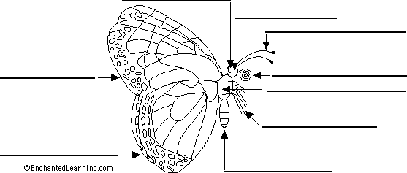](http://www.enchantedlearning.com/label/)