Types of Butterflies: | Weight | Length
Monarch
Zebra swallowtail
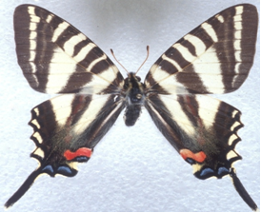
Southern Dogface
Painted Lady
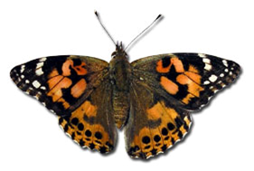
American Snout
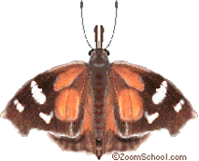
Butterfly measurement Chart

Butterfly Comparing Quiz
(Questions may be read orally)

- Which butterfly weighed the most?

- Which butterfly weighed the least?

- Which butterfly weighed more, the Monarch or Painted lady?

- Which butterfly was longer the Zebra Swallowtail or the American Snout butterfly?

- Which butterfly was the longest?

- Which butterfly was the shortest?

